AI LOAN
ELIGIBILITY CHECKER
Project Documentation Report
PRIYA VILAS ADSUL
Priyaadsul1004@gmail.com

Prepared for project evaluation and submission

Table of Contents

1. Abstract
2. Introduction
3. Problem Statement
4. Objectives
5. Scope of the Project
6. Existing System and Proposed System
7. Technology Stack
8. System Modules
9. System Design and Workflow
10. Implementation Overview
11. Testing and Validation
12. Benefits
13. Limitations
14. Future Enhancements
15. Conclusion
16. Images

1.Abstract

AI Loan Eligibility Checker is a web-based financial assistance platform designed to help users understand important loan-related information before approaching a lender. The platform brings together a loan eligibility checker, credit score analysis, an EMI calculator, and AI-powered financial tips in one interface. It aims to make common financial calculations and guidance easier to access through a simple and user-friendly website. The interface is developed using HTML, CSS, and JavaScript, with a Node.js/Express backend route used to connect frontend requests to an AI service. Claude AI is used to provide AI-generated financial guidance, while Google Sheets is used for project data storage. The tool is intended for preliminary education and estimation; it does not replace a bank's formal credit assessment or professional financial advice.

2. Introduction
Loan decisions can be difficult for people who are unfamiliar with eligibility criteria, credit scores, interest rates, and repayment amounts. Users may need to visit multiple websites or perform calculations manually to understand their financial position. The AI Loan Eligibility Checker combines several useful features in one web application so users can explore estimated eligibility, understand credit-related factors, calculate monthly instalments, and receive general financial tips.
The project follows a clean, modern dashboard-style design with a dark glassmorphism visual theme. Its goal is to improve accessibility and understanding, not to approve or reject real loan applications.

3. Problem Statement
Many users find it challenging to estimate whether they may qualify for a loan and how much repayment they could manage. Information about eligibility, credit scores, and EMIs is often spread across different tools, and manual calculations can lead to confusion. A single, accessible platform is needed to provide preliminary estimates and understandable guidance while clearly communicating that final lending decisions are made by financial institutions.

4. Objectives
- Provide an easy-to-use interface for checking estimated loan eligibility.
- Help users understand factors associated with credit scores and creditworthiness.
- Calculate estimated monthly instalments (EMIs) using loan amount, interest rate, and tenure.
- Offer AI-generated general financial tips in a conversational and accessible way.
- Bring the main financial tools together in one responsive web application.
- Use a backend route to manage communication between the frontend and the AI service.
- Store project data through the configured Google Sheets integration, where applicable.

5. Scope of the Project
The project covers the following functions:
- Preliminary loan eligibility estimation based on information entered by the user.
- Credit Score Analyzer for educational interpretation of credit-related information.
- EMI Calculator for estimating monthly loan repayments.
- AI Financial Tips for general guidance based on a user's question or supplied context.
- A web interface that groups the tools into a consistent dashboard experience.
The application is a student project and is not a lender, credit bureau, or official loan approval system. The accuracy of results depends on the inputs, configured rules, and external AI responses.

6. Existing System and Proposed System

6.1 Existing System
- Users may need to use separate websites for EMI calculations, credit information, and loan eligibility.
- Manual calculations and unfamiliar financial terminology can make the process difficult for beginners.
- General online information may not provide an interactive, consolidated experience.

6.2 Proposed System
- A unified website containing the Loan Eligibility Checker, Credit Score Analyzer, EMI Calculator, and AI Financial Tips.
- A modern interface designed to make common tools easier to locate and use.
- An AI integration to provide general explanatory guidance, supported by a backend endpoint.
- A preliminary educational tool that encourages users to verify requirements with the relevant lender.

7. Technology Stack
Technology | Role | Usage in Project
HTML | Frontend structure | Defines page content and interface elements.
CSS | Visual styling | Provides layout, responsive styling, and dark glassmorphism appearance.
JavaScript | Frontend logic | Handles interactions, input processing, and requests from the interface.
Node.js + Express | Backend | Provides a server-side API/proxy route for frontend requests.
Claude AI | AI assistance | Generates general financial tips or explanatory responses through the configured integration.
Google Sheets | Data storage | Used as the configured storage destination for project data.
Vite | Development tooling | Runs the frontend development server and supports the build workflow.

8. System Modules

8.1 Loan Eligibility Checker
Accepts relevant user-provided financial details and presents a preliminary eligibility result according to the application's configured logic. The result is an estimate only and must not be treated as a lender's decision.

8.2 Credit Score Analyzer
Helps users review credit-related information and understand that repayment history, credit utilisation, existing debt, and length of credit history can affect creditworthiness. Any score interpretation depends on the information and rules implemented in the application.

8.3 EMI Calculator
Estimates the monthly instalment for a loan using principal amount, annual interest rate, and repayment tenure. For a standard fixed-rate reducing-balance loan, the EMI formula is: EMI = P × r × (1 + r)^n / ((1 + r)^n − 1), where P is principal, r is monthly interest rate as a decimal, and n is the number of monthly instalments. If the interest rate is zero, EMI = P / n.

8.4 AI Financial Tips
Connects user prompts to the configured Claude AI service through the backend route and displays generated general financial guidance. Users should avoid entering passwords, bank account credentials, or other unnecessary sensitive information.

8.5 Data Storage Integration
Google Sheets is configured as a project data storage component. The exact fields stored depend on the implemented integration; only necessary information should be recorded and access should be restricted.

8.6 User Interface
Provides a consistent dashboard-style layout with clear sections and a dark glassmorphism visual theme to help users navigate the available financial tools.

9. System Design and Workflow

9.1 High-Level Architecture
- User: enters information or selects a financial tool through the browser.
- Frontend: HTML, CSS, and JavaScript display the interface, validate basic inputs, and initiate requests.
- Backend: Node.js/Express receives relevant API requests and acts as the server-side route for AI-related calls.
- AI service: Claude AI generates a response when the AI Financial Tips feature is used.
- Storage: Google Sheets receives the data configured for storage by the project.

9.2 Typical User Workflow
- Open the application in a web browser.
- Choose the required tool from the dashboard.
- Enter the requested values and check that they are valid.
- Submit the information to calculate an estimate or request AI guidance.
- Review the displayed result and any relevant explanation.
- For actual borrowing decisions, confirm eligibility, fees, interest rates, and terms directly with the lender.

10. Implementation Overview
The frontend is built with HTML, CSS, and JavaScript. The development environment uses Vite for the frontend and an Express server for backend API handling. The AI-related frontend request is routed through the backend rather than placing a private AI API key in browser-side code. Claude AI is the configured AI service, and Google Sheets is the configured storage integration.
During development, the frontend and backend can be run as separate local services. The frontend sends requests to the configured API endpoint, and the backend returns a response for the interface to display. API credentials should be stored in environment variables and should never be committed to a public repository.

11. Testing and Validation
The following test cases form a practical validation checklist for the application. Mark each case as passed only after testing it in the final submitted version.
Test ID | Test Case | Expected Result | Status
T01 | Open the application | Main interface loads without a blank screen or console-breaking error. | verified
T02 | Submit valid EMI inputs | An EMI estimate is displayed using the entered values. | verified
T03 | Submit missing or invalid values | Validation message is shown and invalid calculation is prevented. | verified
T04 | Use loan eligibility tool | A preliminary result is displayed for valid input. | verified
T05 | Use credit score analysis | The tool displays its configured interpretation or guidance. | verified
T06 | Request AI financial tips | Backend handles the request and a response or clear error message is displayed. | verified
T07 | Check backend/API failure | The interface handles failure without crashing or displaying malformed output. | verified
T08 | Check responsive layout | Content remains usable at supported desktop and mobile widths. | verified

12. Benefits
- Combines multiple basic financial tools in one application.
- Reduces the need for manual EMI calculations.
- Makes financial concepts more approachable for users who are new to borrowing.
- Provides interactive, AI-generated general guidance.
- Demonstrates frontend, backend, API integration, and data-storage concepts in a single project.

13. Limitations
- Eligibility estimates may not include every lender-specific rule, fee, or underwriting factor.
- Credit score interpretation is limited by the data and logic available in the application; it is not an official credit report.
- AI-generated guidance can be incomplete or inaccurate and should be independently verified.
- AI features depend on network connectivity, API availability, correct credentials, and service limits.
- Google Sheets is suitable for a student prototype but may not provide the security, access control, or scale required for a production financial service.
- The application does not issue loans, guarantee approval, or replace professional financial advice.

14. Future Enhancements
- Add secure user authentication and role-based access where required.
- Improve eligibility estimates with clearly documented rules and lender-specific criteria.
- Add downloadable calculation summaries and a history of user calculations, with suitable privacy controls.
- Improve accessibility, mobile responsiveness, and input validation.
- Add multilingual explanations and financial-literacy resources.
- Replace prototype storage with a secure production database if the project is scaled.
- Add automated unit, integration, and end-to-end tests.
- Display transparent disclaimers, assumptions, and the date of any financial information used.

15. Conclusion
The AI Loan Eligibility Checker demonstrates how a web application can bring together common loan-related calculations and general financial guidance. Its four core tools—Loan Eligibility Checker, Credit Score Analyzer, EMI Calculator, and AI Financial Tips—aim to help users explore financial information through a single interface. The project also demonstrates the integration of frontend technologies, a Node.js/Express backend, Claude AI, and Google Sheets. With further testing, stronger privacy and security controls, and clearer documentation of calculation rules, the prototype could be developed into a more complete financial education platform.

16.Images
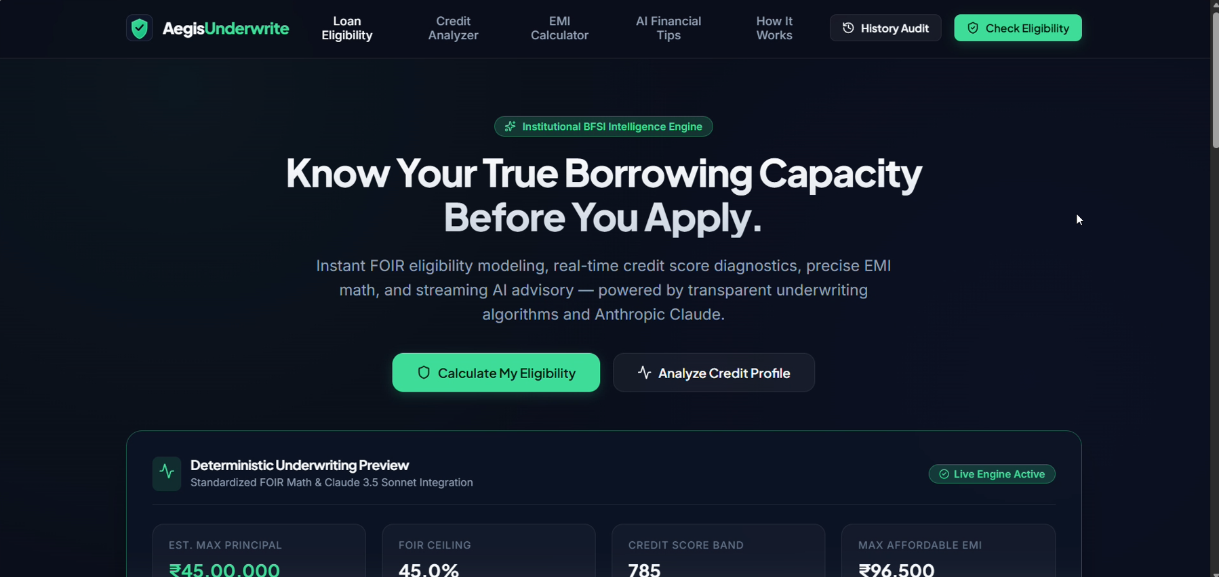

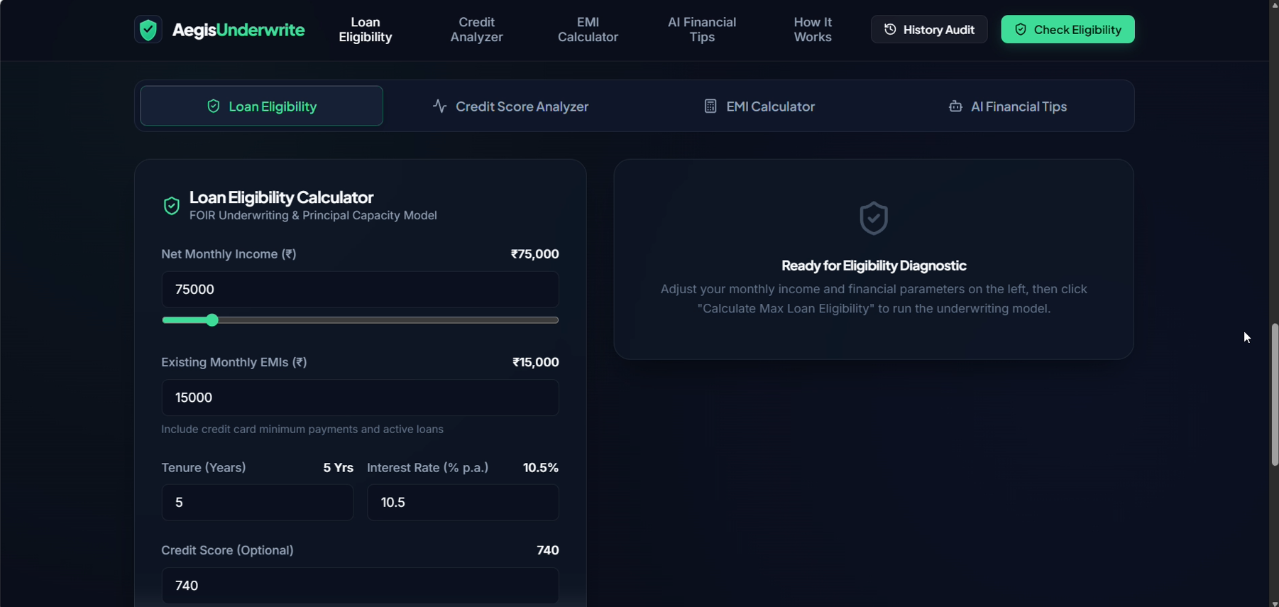

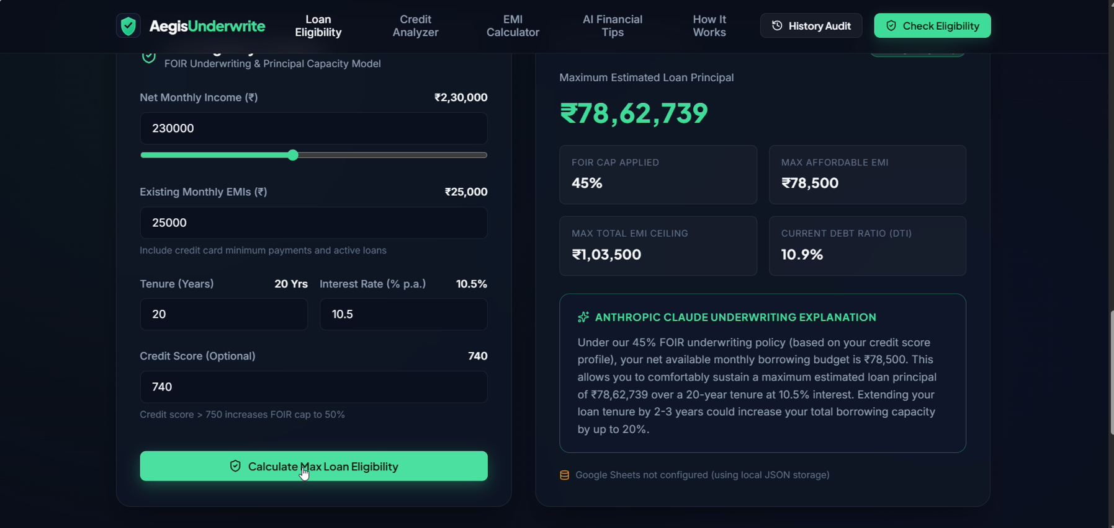

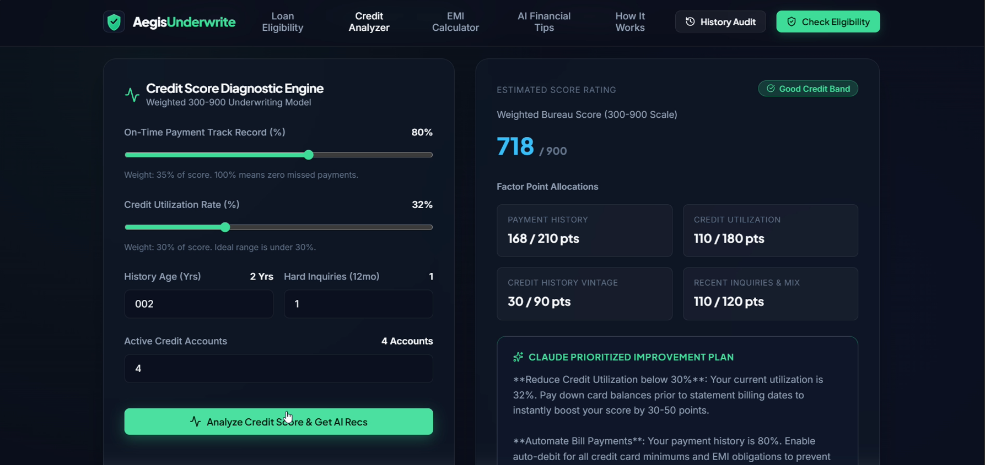

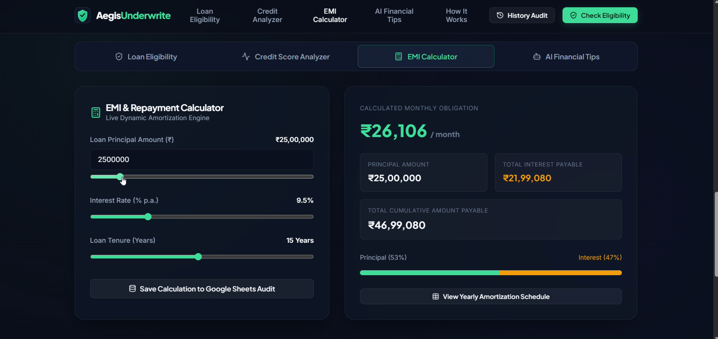

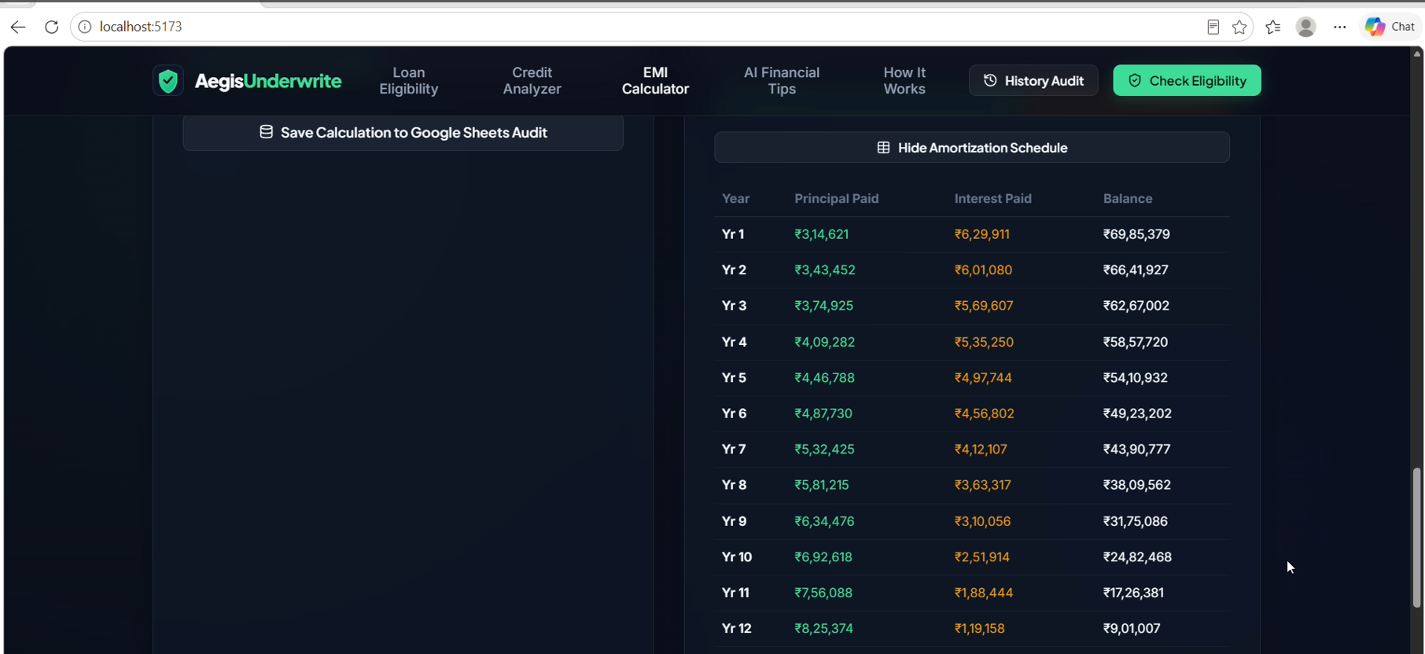

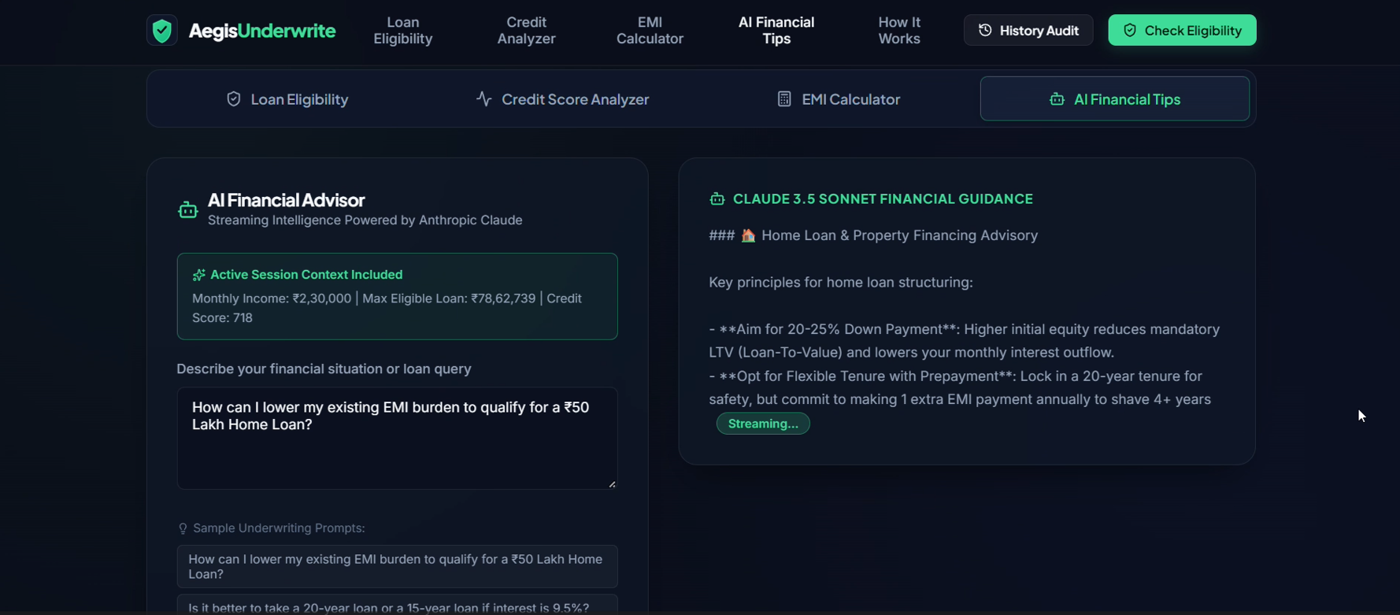

— End of Documentation —

